DESIGN AND IMPLEMENTATION OF A QR CODE BASED DIGITAL BUSINESS CARD SYSTEM

BY
OYAKHIRE MAHMUD NANA AISHAH
FSC/CSC/22004016
A PROJECT SUBMITTED IN PARTIAL FULFILLMENT OF THE REQUIREMENTS FOR THE AWARD OF THE DEGREE OF BACHELOR OF SCIENCE (B.Sc.) IN COMPUTER SCIENCE, EDO UNIVERSITY, IYAMHO.
FEBRUARY, 2026
DECLARATION
This project is my original work and has not been presented for a degree in any other university. No part of this project may be reprodu6ced without the prior written permission of the author and/or Edo University, Iyamho.

…………………………………………………………..
OYAKHIRE MAHMUD NANA AISHAH
Date: ………………………………………………….

APPROVAL
This is to certify that OYAKHIRE MAHMUD NANA AISHAH undertook this project work DESIGN AND IMPLEMENTATION OF A QR CODE BASED DIGITAL BUSINESS CARD SYSTEM and meets the requirements for submission to the Department of Computer Science, Edo University Iyamho, in partial fulfillment for the award of Bachelor of Science (B.Sc.) Computer Science Degree.

…………………………. .. | ……………………………..
Dr. O. O. Uddin  (Project supervisor) | Date
…………………………. .. | ……………………………..
Dr. S. Omaji  (Head of Department) | Date
…………………………. .. | ……………………………..
Professor---------------- | Date
External Examiner

DEDICATION
This project is dedicated to Almighty God who have showed me love, strength and also kept me fit till today, dedicated and focused on my achievement to my success.

ACKNOWLEDGEMENTS
I am profoundly grateful to Almighty God, whose boundless grace, divine guidance, and unwavering faithfulness have sustained me throughout the course of this research. His wisdom and strength have been my constant anchor and source of inspiration.
I wish to extend my deepest appreciation to my supervisor, Dr. O. O. Uddin for his exceptional guidance, invaluable insights, and steadfast support. His constructive feedback, scholarly expertise, and patient mentorship have been pivotal to the successful completion of this work.
I am equally indebted to the Head of Department, Computer Science, Dr. S. Omaji, for his leadership and encouragement, and to all the esteemed lecturers of the Department of Computer Science, Edo State University, Iyamho. My heartfelt thanks go to Prof. A. J. Jegede, Dr. J. O. Nehinbe, Dr. G. N. Edegbe, Dr. A. S. Makinde, Dr. J. T. Ogbiti, Dr. O. O. Uddin, Dr. T. O. Asunogie, Dr. O. J. F. Umoru, Mr. A. Okosun, Miss B. Olumhense, and Miss May, for their commitment to academic excellence and for imparting the knowledge and skills that have shaped my intellectual development.
My sincere appreciation also goes to my colleagues and peers for their collaboration, insightful discussions and constructive feedback, which have contributed significantly to the quality of this research.
I specially thank my wonderful parents for their unending love, support, prayers and guidance. Your sacrifices have made this achievement possible. My heartfelt gratitude goes to my siblings for their love and support.
Finally, my love and gratitude go out to my dear friend, Honour Onovae Oghenefejiro who consistently encouraged me till the successful end of this research. I specially thank Fareedah, Peculiar, and all my friends who made sure this research was a success.

ABSTRACT

Traditional paper business cards are widely used for professional networking but face significant limitations, including high printing costs, static information that becomes obsolete once printed, and a lack of engagement analytics. This project designs and implements a Dynamic QR Code-Based Digital Business Card System to provide a flexible and cost-effective alternative. Unlike commercial platforms requiring paid subscriptions or native apps, this system utilizes a device-independent web responsive application to ensure instant access without device compatibility issues. The core of the study is the implementation of a dynamic redirection algorithm. This technical approach involves encoding a unique User Resource Locator (URL) into a QR image, linking to a centralized MySQL database. By decoupling the physical code from the stored data, the system allows users to modify their professional profiles, including contact details and social media integrations in real-time without the need to regenerate the physical QR code. The resulting prototype offers an eco-friendly, scalable, and low-latency solution for professional identity management, successfully bridging the gap between physical networking and modern digital connectivity.

TABLE OF CONTENTS
APPROVAL iii
DEDICATION iv
ACKNOWLEDGEMENTS v
ABSTRACT vi
TABLE OF CONTENTS vii
LIST OF TABLES viii
CHAPTER ONE 1
INTRODUCTION 1
1.1 Background of the Study 1
1.2 Statement of the Problem 2
1.3 Aim and Objectives 3
1.4 Scope of the Study 3
1.5 Significance of the Study 4
1.6 Limitations of the Study 5
1.7 Definition of Terms 6
1.8 Organization of the Study 7
CHAPTER TWO 8
LITERATURE REVIEW 8
CHAPTER THREE 22
SYSTEM ANALYSIS AND DESIGN 22
REFERENCES 31

LIST OF TABLES

Table 1 Summary of Related Works……………………………………...19
LIST OF FIGURES
Figure 3.1 Overview Design of the Proposed System……………………………24
Figure 3.2 Waterfall Methodology………………………………………….…….25
Figure 3.3 Use Case Diagram for the Proposed System………………………….27
Figure 3.4 Database Design Structure……………………………………………30

CHAPTER ONE

INTRODUCTION

Background of the Study
Business cards have come a long way from their origins as simple paper cards. What started as a basic tool for sharing contact information has evolved into a versatile marketing asset (Khatri, 2025). For decades, physical paper has been a staple for professional identity. However, this method has proven over time to be one-way. Once printed, the card cannot be tracked or updated.
Business cards still serve a role in establishing one’s identity and status before a conversation even begins. They provide context about who you are and what position you hold. Before someone even takes the effort to save your number or check out your website, they can quickly assess whether they want to connect with you. Business cards still have a creative design element; they’re not just about displaying a name, but about branding as well. However, they are limited in space, which is why QR codes can be especially valuable (Forbes, 2025).
A QR Code on a business card is a modern networking tool that embeds a scannable QR Code, allowing instant access to your contact details. Adding a QR Code to your business cards makes it easy for prospects, leads, or potential employers to save your information with a quick scan, eliminating the hassle of manual data entry. You can link your QR Code to your social profiles (Instagram, LinkedIn, Facebook), portfolio, website, or resume, and print it on your business card for a professional and memorable first impression (Uniqode, 2021-2026).
This project aims to design and develop a digital business card system using QR code technology, specifically designed to suit the university and local business environment. The proposed system should enable users to generate digital business cards, produce QR codes, and share these QR codes to anybody, anywhere, anytime, using either a mobile device or print copies, as well as allowing viewers to immediately scan and store contacts by simply scanning the code using a QR code-scanning mobile app owned by the viewer.

Statement of the Problem
The reliance on traditional, paper-based business cards introduces significant inefficiencies and limitations in modern professional networking, primarily stemming from their static nature. Once printed, the information displayed on a physical card is immutable, meaning any updates to an individual's contact details, job title, or organizational affiliation necessitate reprinting the entire batch, which highlights a severe lack of data synchronization and agility (Jones & Smith, 2023). This inability to update information in real-time not only leads to wasted resources but also results in recipients holding outdated contact information, thereby diminishing the effectiveness of the initial interaction (Brown, 2022). Furthermore, the continuous printing of these cards imposes a substantial recurring economic burden on organizations while simultaneously contributing to significant paper waste, raising serious concerns regarding environmental sustainability and hazards (Wilson et al., 2024).
Beyond the limitations of static content and environmental impact, physical business cards are inherently fragile and vulnerable to damage from daily handling, leading to the loss or degradation of crucial contact information (Davis & Miller, 2023). This lack of durability poses a substantial risk to professional networking efforts, as vital connections can be permanently lost if a card is damaged or misplaced (Thompson, 2021). The process of digitizing the information contained on these cards is equally problematic; the manual data entry required to transfer physical details into a digital CRM or contact list is exceptionally slow, labor-intensive, and prone to human errors, resulting in significant data clutter and reduced productivity (Evans, 2025). Finally, traditional cards offer no mechanism for tracking engagement or measuring the efficacy of networking activities. Consequently, it is impossible to determine whether a card was actually saved, utilized, or referred to by the recipient, which represents a critical absence of analytics and feedback essential for optimizing networking strategies and understanding return on investment (Lee & Garcia, 2024).

Aim and Objectives
Aim
To design and implement a QR code-based digital business card system.​
Objectives
- To design the architecture of a QR code-based digital business card system, including user interface, backend services, and database structure.​
- To implement QR code generation and scanning functionality using standard formats such as vCard and/or URL-based profiles.​

Scope of the Study
This study focuses on the design and implementation of a QR code-based digital business card system. The scope is action-oriented and covers the practical development activities required to build and test a functional system prototype.
The study will:
- Design the overall system architecture for a QR code-based digital business card platform.
- Design the user interface for creating, editing, and viewing digital business cards.
- Develop a user registration and authentication module.
- Implement digital business card creation and management functionalities.
- Integrate QR code generation for each digital business card.
- Implement QR code scanning functionality to enable quick access to shared contact information.
- Develop a contact storage and retrieval module for managing saved digital cards.
- Design and implement a secure database for storing user and card information.
The study is limited to the development of a functional prototype and does not extend to advanced enterprise-level CRM features or large-scale commercial deployment.

Significance of the Study
This research offers practical benefits for three primary stakeholder groups while contributing to academic literature on digital networking systems.
For professionals and students, the proposed system addresses the longstanding inability to measure networking effectiveness. Unlike paper cards, which provide no feedback once distributed, the digital platform enables users to track how frequently their cards are viewed, shared, or saved (Hwang et al., 2020). This visibility allows users to assess which networking contexts generate meaningful engagement and adjust their professional outreach accordingly. Additionally, the integration of clickable links to LinkedIn profiles, personal websites, and online portfolios transforms the business card from a static information carrier into an interactive gateway for professional discovery (Pitt et al., 2011). For students and early-career professionals whose credentials often reside in project work rather than job titles, this multimedia capacity offers a more complete representation of their capabilities than traditional paper formats permit.
For organizations, the system reduces the recurrent expenditure associated with bulk printing and reprinting when employee information changes (Lubin & Esty, 2010). This operational efficiency is accompanied by measurable environmental benefits, as the displacement of paper cards reduces material consumption and waste generation. Organizations adopting such systems may simultaneously lower costs and demonstrate commitment to sustainable practices, an increasingly salient dimension of corporate reputation management (Babiak & Trendafilova, 2011).
For academic research, this study extends the limited scholarship examining QR code applications beyond marketing and logistics into professional networking contexts (Okazaki et al., 2017). By designing and validating a functional prototype for under-resourced user groups students, lecturers, and small business owners the research tests whether sophisticated contact management capabilities can be successfully instantiated within lightweight, accessible architectures suitable for users who lack enterprise-grade infrastructure (Venkatesh et al., 2012).

Limitations of the Study
Despite the relevance and potential benefits of the proposed system, certain constraints may affect its implementation and overall performance. These limitations are outlined below:
- The system depends on a stable internet connection and supporting technological infrastructure to function effectively.
- Lack of regular updates and maintenance may result in outdated information or broken links, reducing system reliability.
- QR codes are primarily suitable for direct, one-to-one information sharing, which may limit effectiveness in low-connectivity or crowded networking environments.
- Older professionals or individuals with limited digital literacy may face difficulties in adopting and using the system.
- Poorly generated or low-quality QR codes may lead to scanning failures and reduced usability.
- Inadequate security implementation may expose sensitive user data to unauthorized access or cyber threats.

Definition of Terms
QR Code (Quick Response Code): A 2D matrix barcode scanned on smart devices to gain access to digital data.
vCard: A digital file format .vcf (Virtual Contact File) extension, containing information such as name, address, email and URL information, allowing the recipient to save contact details directly to their phone directory.
Digital business cards: An electronic version of a paper business card that allows instant sharing of digital data amongst users, creating an eco-friendly and interactive environment.
Encryption: The conversion of data from a readable format into an encoded format. Encrypted data can only be read or processed after it's been decrypted.
Dynamic QR Code: A flexible, editable, and trackable 2D barcode that uses a short redirection URL, allowing the destination content to be changed after printing.
Static QR Code: A QR code that is fixed and cannot be changed or updated once created.
NFC (Near Field Communication): A technology used in physical, smart cards that allows for instant, touchless sharing of a digital business card when tapped against a phone.
URL (Uniform Resource Allocator): A web address used to locate resources such as websites, images or documents on the internet.

Organization of the Study
Chapter One: Chapter One presents an overview on the background, aim and objectives, research questions, problem statement, significance of study, and limitations of study.
Chapter Two: Literature Review on the subject matter
Chapter Three: System Analysis and Design of the proposed system
Chapter Four: Implementation and Testing of the proposed system
Chapter Five: Summary, Conclusion and Recommendations on this study

CHAPTER TWO

LITERATURE REVIEW
2.1 Introduction
This chapter provides relevant literature on QR code technology, digital business cards, and related web-based systems. It examines key concepts, existing systems and identifies research gaps that justify the proposed QR code based digital business card system.

2.2 Conceptual Framework
Business cards have long served as a standard tool for exchanging professional contact information. Their small size and ease of distribution make them convenient for brief networking encounters at conferences, meetings, and other professional gatherings (Cameron & Webster, 2013). However, traditional paper business cards present notable limitations. Once printed, the information they contain cannot be updated. When a phone number, email address, or job title changes, an entirely new card must be printed. This makes paper cards inherently static and difficult to maintain (Hwang et al., 2020). Additionally, the physical size of a standard card restricts how much information can be included, making it impossible to share online portfolios, social media profiles, or other rich media content (Pitt et al., 2011).
The widespread adoption of smartphones and reliable internet access has changed how people store and manage contact information. Most mobile devices now allow users to save contacts directly, integrate them with communication applications, and synchronize them across multiple devices through cloud services (Venkatesh et al., 2012). Within this environment, digital alternatives to paper cards have emerged. These alternatives offer greater flexibility by allowing users to update their information in real time and share more comprehensive professional profiles (Okazaki et al., 2017).
This project is built upon three core concepts: Quick Response (QR) code technology, digital business cards, and dynamic linking to web-based profiles. QR codes are two-dimensional barcodes that can be scanned by smartphone cameras to quickly retrieve encoded information (Rouillard, 2008). Digital business cards replace physical cards by storing contact information electronically, enabling users to modify their details without reprinting (Narayana & Sreeram, 2020). Dynamic linking refers to the practice of encoding a QR code with a web address rather than fixed text. When scanned, the code directs users to an online profile that can be updated at any time, ensuring that the information received is always current (Liu et al., 2021). Together, these concepts form the foundation of a system that allows users to generate, share, and maintain digital business cards while remaining compatible with existing practices such as printing cards that carry embedded QR codes.

2.2.1 Quick Response (QR) Code Technology
Quick Response (QR) codes are two-dimensional matrix barcodes capable of encoding alphanumeric characters, uniform resource locators, and other structured data within a compact pattern readable by camera-equipped mobile devices (Rouillard, 2008). Originally developed for automotive manufacturing tracking, QR codes have since been adopted across diverse domains including marketing, payment systems, user authentication, and information sharing. Their widespread use is attributed to high storage capacity, rapid decoding speed, and tolerance for partial damage through embedded error correction mechanisms (Liu et al., 2021).
Unlike traditional one-dimensional barcodes, which store data horizontally only, QR codes store information in both horizontal and vertical dimensions, enabling significantly greater data density (Ting et al., 2021). When scanned, the encoded content is decoded by the mobile device and passed to the appropriate application a web browser for URLs or a contacts application for vCard data. This functionality positions QR codes as effective bridges between physical media, such as printed cards, and digital resources, including web-based profiles and electronic contact forms (Narayana & Sreeram, 2020).
Two principal categories of QR codes are identified within the literature: static and dynamic. Static QR codes contain the final content directly, whether plain text, a telephone number, or an email address, and cannot be altered once generated (Rouillard, 2008). Dynamic QR codes, by contrast, store only a brief redirection link pointing to a remotely hosted server. The destination content may be updated on the server at any time without modification to the printed code itself (Liu et al., 2021). For professional networking and digital business card applications, dynamic QR codes are preferable because they permit users to revise their contact details after physical cards bearing the code have already been distributed (Hwang et al., 2020).
Dynamic QR codes additionally support the collection of engagement analytics. Each scanning event may be logged on the server, capturing metadata such as time of access, Internet Protocol address, approximate geographic location, and device type (Okazaki et al., 2017). These logs can be aggregated to furnish insights regarding scan frequency, preferred platforms, and temporal patterns of networking activity. Such analytics are entirely unattainable through traditional paper cards and directly address the deficiency of performance feedback identified within the problem statement (Gremyr et al., 2021).​​

2.2.2 vCard and Digital Contact Formats
The vCard, or Virtual Contact File, is an established electronic format for storing and exchanging personal contact information. A standard vCard typically contains fields for name, telephone numbers, email addresses, organization, job title, and website URLs. Files in this format use the ".vcf" file extension and can be imported directly into the address books of most smartphones, email clients, and contact management applications (Howes et al., 2004). Over time, this standard has emerged as the de facto format for digital business card exchange across numerous platforms and systems (Parsons & Telek, 2020).
When a QR code encodes a vCard payload, scanning the code triggers the mobile device to interpret the data as a contact file. The operating system then opens the device's address book application and displays the contact information, allowing the user to review and save the details with a single action (Narayana & Sreeram, 2020). An alternative approach involves encoding a URL within the QR code that directs the scanner to an online profile page. From this page, the user may either manually copy the information or save the contact automatically through additional scripts or integrations (Ting et al., 2021).
The decision to embed vCard data directly or to link to a hosted profile carries distinct implications for system design, flexibility, and long-term maintainability. Embedding vCard data within a static QR code is technically simple and requires no server infrastructure. However, this approach renders the encoded information immutable; any change to the cardholder's contact details necessitates generating a new QR code and redistributing printed materials (Rouillard, 2008). Conversely, linking to a web-based profile through a dynamic QR code introduces requirements for server hosting and database management. This approach enables continuous updating of contact information without modification to the distributed QR code itself (Liu et al., 2021). The proposed system adopts this dynamic method, encoding profile URLs that resolve to database records, thereby permitting users to revise their professional details at any time after physical cards have been circulated (Hwang et al., 2020).

2.2.3 Digital Business Cards
Digital business cards are electronic representations of traditional paper business cards. They may be shared through various channels including URLs, Quick Response codes, electronic mail, and near field communication technology (Hwang et al., 2020). Unlike physical cards, digital formats permit the embedding of richer information beyond the constraints of a small printed surface. This includes hyperlinks to social media profiles, professional portfolios, location maps, and multimedia content (Pitt et al., 2011). Because digital cards are not committed to physical substrate, users may update their professional details whenever roles or contact information change, eliminating the recurring expense and delay associated with reprinting large batches of paper cards (Kim & Lee, 2020).
Existing literature and industry reports identify several advantages of digital business card systems. First, they offer environmental benefits through the reduction of paper consumption and the elimination of printing-related waste and expenditure (Lubin & Esty, 2010). Second, they enhance interactivity by presenting recipients with clickable telephone numbers, electronic mail addresses, and uniform resource locators, thereby circumventing the manual transcription errors and time costs associated with paper-based data entry (Narayana & Sreeram, 2020). Third, digital cards may be integrated with analytics engines capable of recording how frequently a card is viewed, opened, or forwarded. This feedback furnishes users with previously unavailable visibility into the effectiveness of their networking activities (Gremyr et al., 2021).
A range of commercial platforms currently enables users to create digital business cards, customize visual appearance, and generate QR codes linking to cloud-hosted profile pages. These platforms commonly provide web-based design interfaces, layout templates, secure data storage, and administrative dashboards displaying scan statistics (Okazaki et al., 2017). Nevertheless, many such solutions are generic in orientation, operate on subscription-based revenue models, or are engineered for the requirements of large corporate clients. Few are customized to the specific constraints and use cases of academic institutions, university students, or small local enterprises (Venkatesh et al., 2012).

2.2.4 Security and Privacy in QR-Based Systems
The deployment of Quick Response codes introduces several security and privacy vulnerabilities that require careful consideration during system design. Attackers may generate and distribute malicious QR codes that redirect unsuspecting users to phishing websites, initiate downloads of unwanted or harmful applications, or exfiltrate data to unauthorized remote servers (Liu et al., 2021). Where digital business card platforms transmit profile information without adequate encryption, sensitive personal data such as electronic mail addresses and telephone numbers may be intercepted over insecure network connections (Krombholz et al., 2014). Additionally, poorly implemented dynamic QR systems may expose unique user identifiers in predictable patterns, enabling unauthorized parties to access or modify profile information belonging to other users (Rouillard, 2008).
To address these threats, researchers and practitioners have proposed several countermeasures. Secure communication channels enforced through HTTPS encryption are considered a minimum requirement for protecting data in transit (Focardi et al., 2019). Server-side input validation is necessary to prevent injection attacks and other malicious payloads. Authentication mechanisms, typically implemented through user login credentials, ensure that only authorized individuals may modify their own profile information. Authorization controls further restrict access to privileged operations such as account deletion or data export (Liu et al., 2021). For digital business card applications specifically, designers must determine which information appears on publicly accessible profile pages and which remains restricted to authenticated users or trusted contacts (Hwang et al., 2020). These security considerations directly inform the design decisions and implementation choices made within the proposed system.

2.2.5 Review of Related Works
Several research works and commercial systems have applied Quick Response code technology to contact management, professional networking, and digital business card applications. This section reviews twelve existing systems and studies, examining their respective contributions, methodological approaches, and identified limitations to situate the proposed project within the broader scholarly and industrial landscape.
Luo and Cheng (2016) developed a patented system for a business card configured with dynamic two-dimensional code information. The system employed cloud storage architecture wherein each printed QR code pointed to a database containing editable data tables, and multiple cards belonging to the same user could be grouped under a single card case code with synchronized updating capabilities. The approach permitted cardholders to modify their information after card distribution without code regeneration. However, the system was patented in 2016 and does not appear to have been implemented as a publicly available platform. It lacked modern web technologies, mobile-responsive design considerations, and integrated analytics functionality.
Shenzhen Weike Technology (2022) patented an electronic business card interaction method and system based on smart wearable devices. The system identified handshake actions through sensors embedded in smart watches and automatically exchanged business cards via near field communication or Bluetooth protocols. Cloud servers synchronized and backed up card data across multiple devices. The research addressed the friction of manual exchange and the inconvenience of mobile phone QR code display. However, the system introduced dependency on specialized wearable hardware not widely adopted by the target demographic. Its complexity and hardware requirements rendered it inaccessible to average students or small business owners, and the system has not achieved commercial proliferation.
Bhamidipati and Wvs (2022) proposed a novel approach to ensure security and privacy during QR code scanning in business applications. The study employed cryptographic techniques to protect sensitive information transmitted through QR code channels. The approach addressed growing concerns regarding phishing, pharming, and data interception vulnerabilities. Nevertheless, the research remained conceptual and did not produce an implemented, evaluated prototype specifically tailored for digital business card exchange.
An anonymous author or authors (2022) proposed a secured QR method incorporating Advanced Encryption Standard cryptography to protect QR code payloads. The approach secured QR codes through a key on the generator side, with the same key required to retrieve original information at the scanner side. The method was positioned as applicable to sharing profile details, business cards, and payment information within organizational contexts. However, the research did not address the dynamic updating requirements central to digital business card systems and provided no implementation framework for contact management or networking analytics.
The Digital Spotlight Coffee mastermind session, documented by Davis (2025), identified critical deficiencies in existing digital business card systems through collaborative professional analysis. The session revealed that most QR code systems facilitate only one-sided data exchange, provide weak downstream visibility, and fail to address what participants termed the follow-up black hole, wherein collected contacts dissipate within 48 hours of initial exchange. The group designed an intelligent networking process wherein QR scans trigger data capture forms that feed directly into customer relationship management systems for automated follow-up sequences. While this model advanced the conceptual framework for digital business cards, it was presented as strategic guidance rather than an implemented, evaluated system with empirical validation.
Mobilo Card (2026a) documented QR code scan tracking and analytics methodologies through industry case studies. The report indicated that 85% of businesses reported increased networking efficiency when QR integration was treated as a tracked touchpoint. The company's approach employed dynamic QR codes with redirect servers that captured device type, operating system, scan time, and approximate location. A 60-day pilot demonstrated that routing by city and time reduced average lead response time from 48 hours to 6 hours and increased qualified callbacks by 2.5 times. However, the platform operates on a subscription-based commercial model, and the research was published as proprietary industry reporting rather than peer-reviewed academic literature. Specific implementation details and full methodological transparency were not provided.
Mobilo Card (2026b) further examined the effectiveness of QR codes on business cards, reporting that 45% of business cards with QR codes drive increased engagement and that 87% of users find QR codes on business cards useful. The research identified four persistent failure modes: trust and security vulnerabilities, accessibility gaps for users without camera-enabled devices, analytics noise from bot traffic and internal testing, and brand drift from ungoverned individual code generation. The company proposed centralized QR provisioning, single sign-on role controls, and customer relationship management synchronization as solutions. These findings contributed valuable empirical data regarding user acceptance, but remained commercial research with inherent product promotion objectives.
Alibaba Product Insights (2025) published a technical overview of dynamic QR code applications, including vCard formats for business networking. The document detailed that dynamic vCard QR codes permit instant contact saving, reduce manual entry errors, and support full contact details including email, telephone, title, company, and website. Limitations identified included confinement to contact data only, compatibility issues with older devices, and the requirement for reconfiguration when changes were necessary unless dynamic hosting was employed. The overview acknowledged that vCard QR codes typically offer only limited analytics, generally restricted to scan counts rather than comprehensive engagement metrics. The document was published as commercial product guidance rather than peer-reviewed research and lacked citation of primary studies.
University of Idaho Parks and Recreation Lab (2025) conducted a case study examining QR code business cards as a survey data collection instrument. The study compared responses from visitors who completed surveys on on-site tablets against those who responded via QR code printed on business cards distributed at national parks. Results revealed no meaningful statistical differences between the two groups, validating the QR code business card method as a viable approach for reaching broader audiences. While this study empirically validated QR code business cards as data collection instruments, its focus was survey methodology rather than professional networking, contact management, or dynamic information updating. The system employed static QR codes with fixed destinations and did not incorporate analytics tracking or user profile management.
A systematic literature review by an anonymous author or authors (2024) examined QR code technology in relation to cryptographic models and card payment systems. The review analyzed over 25 peer-reviewed publications from 2015 to 2025, identifying research gaps in lightweight cryptographic models suitable for mobile and low-resource environments. While this review comprehensively addressed QR code security and payment integration, it did not specifically examine digital business card applications, contact management systems, or professional networking use cases. The review confirmed the broader reliability and versatility of QR technologies across multiple domains but did not contribute directly to the digital business card literature.
The patented system by Luo and Cheng (2016) has already been discussed. This work remains significant as an early formalization of dynamic QR principles specifically applied to business cards, demonstrating technical feasibility prior to widespread commercial adoption. However, its status as un-implemented intellectual property limits its contribution to the body of evaluated, deployable systems.
The smart wearable system by Shenzhen Weike Technology (2022) represents an innovative approach to reducing interaction friction through automatic exchange triggered by physical gestures. Nevertheless, the hardware dependency and lack of demonstrated adoption among the target demographic constrain its applicability to the present study's focus on accessible, lightweight solutions for under-resourced users.
In summary, existing systems and studies demonstrate the technical feasibility and growing market acceptance of QR code-based digital business cards. Dynamic updating, analytics collection, and multimedia embedding have been successfully implemented across commercial platforms and documented in patent literature. However, several persistent limitations are evident. First, the most sophisticated systems are commercially operated with subscription costs that create barriers for students, lecturers, and small business owners operating on limited budgets. Second, existing platforms are predominantly designed for general enterprise use and lack customization for academic networking contexts such as conferences, career fairs, and departmental events. Third, freely accessible solutions typically sacrifice critical functionality static codes cannot be updated, analytics are absent, or contact management interfaces remain rudimentary. Fourth, several innovative approaches documented in patent literature have not been realized as implemented, evaluated systems available to end users. The proposed study addresses these gaps by developing a lightweight, mobile-responsive web application tailored specifically to the networking needs of university students, faculty, and local small business owners, incorporating dynamic QR updating, basic engagement analytics, and contact management within an accessible, non-commercial framework.

Table 1: Summary of Related Works
SN | Author/Year | Work Done | Methodology | Limitations
1 | Luo & Cheng (2016) | Developed a dynamic QR-enabled business card system with cloud storage, allowing multiple cards per user and synchronized updates | Cloud-based architecture, patented system | Not publicly implemented, lacks modern web/mobile design and analytics
2 | Shenzhen Weike Technology (2022) | Electronic business card system using smart wearables for automatic exchange via gestures | Wearable sensors, NFC/Bluetooth, cloud synchronization | Hardware dependency, complex, not widely adopted, limited accessibility
3 | Bhamidipati & Wvs (2022) | Proposed secure QR scanning using cryptography | Cryptographic techniques | Conceptual only, no prototype or implementation for business cards
4 | Anonymous (2022) | Secured QR method using AES encryption for payloads | AES cryptography | No dynamic updating, no implementation framework for contact management or networking
5 | Davis (2025) | Identified deficiencies in digital business cards and proposed intelligent networking workflow | Collaborative professional analysis, strategic guidance | Conceptual only, no implemented system, lacks empirical validation
6 | Mobilo Card (2026a) | QR scan tracking and analytics to improve networking efficiency | Dynamic QR codes, redirect servers, pilot study | Proprietary, subscription-based, not peer-reviewed, limited methodological transparency
7 | Mobilo Card (2026b) | Studied user engagement and QR failures on business cards | Commercial user research, empirical reporting | Commercial bias, product promotion, limited peer-reviewed validation
8 | Alibaba Product Insights (2025) | Technical overview of dynamic vCard QR codes for networking | Documentation/Technical overview | Limited to contact data, compatibility issues, limited analytics, commercial guidance
9 | University of Idaho Parks & Rec Lab (2025) | Evaluated QR code business cards as survey tools | Case study, comparative survey | Focused on surveys, static QR codes, no analytics or dynamic profile management
10 | Anonymous (2024) | Systematic review of QR code tech in cryptography and payments | Literature review of 25+ studies | Did not examine digital business cards or networking, focused on security/payment
11 | Luo & Cheng (2016) [Repeated] | Early formalization of dynamic QR for business cards | Patented system, technical feasibility | Unimplemented IP, limits practical evaluation
12 | Shenzhen Weike Technology (2022) [Repeated] | Gesture-based QR exchange via wearables | Hardware-dependent automatic exchange | Hardware dependency, lack of adoption limits accessibility

CHAPTER THREE

SYSTEM ANALYSIS AND DESIGN
3.1 Introduction
This chapter presents the system analysis and design of the QR code-based digital business card system. It explains how the existing system operates, identifies its limitations, and describes the proposed solution. The chapter further outlines the design methodology, system architecture, and relevant system models and diagrams. It also presents the database design architecture that supports the implementation of the system.

3.2 System Analysis
System analysis involves examining the current method of sharing business card information, identifying its weaknesses, and defining the functional and non-functional requirements of the proposed system.
The goal of this analysis is to ensure that the new system effectively addresses the limitations of traditional and existing digital contact-sharing methods.

3.2.1 Analysis of the Existing System
The existing system of sharing business contact information is largely based on:
- Paper-based business cards
- Manual contact sharing (verbal exchange or text messages)
- Static digital cards shared via social media or messaging platforms
Characteristics of the Existing System
- Contact details are printed on physical cards.
- Information is shared manually through messaging platforms.
- Updates require reprinting of cards or resending new details.
- No centralized system for managing shared contacts.
Limitations of the Existing System
- High cost of printing and reprinting paper cards.
- Risk of loss, damage, or misplacement of physical cards.
- Difficulty in updating contact information once printed.
- Lack of interactivity and dynamic features.
- Inefficient storage and retrieval of collected contacts.
These limitations highlight the need for a more efficient, digital, and dynamic solution.

3.2.2 Analysis of the Proposed System
The proposed system is a QR code-based digital business card platform designed to enable users to create, manage, and share contact information digitally.
Key Features of the Proposed System
- User registration and authentication
- Digital business card creation and editing
- Automatic QR code generation
- QR code scanning for instant access to contact details
- Secure storage of user and card information
- Mobile-responsive web interface
Advantages of the Proposed System
- Easy and instant sharing of contact details through QR codes
- Real-time updating of information without reprinting
- Reduced cost compared to paper cards
- Improved organization and management of contacts
- Enhanced accessibility across multiple devices
The proposed system provides a modern and efficient alternative to traditional business cards.

3.3 System Design
System design describes how the proposed system will be structured and implemented to meet the identified requirements. It defines the technical framework, architecture, and models that guide development.
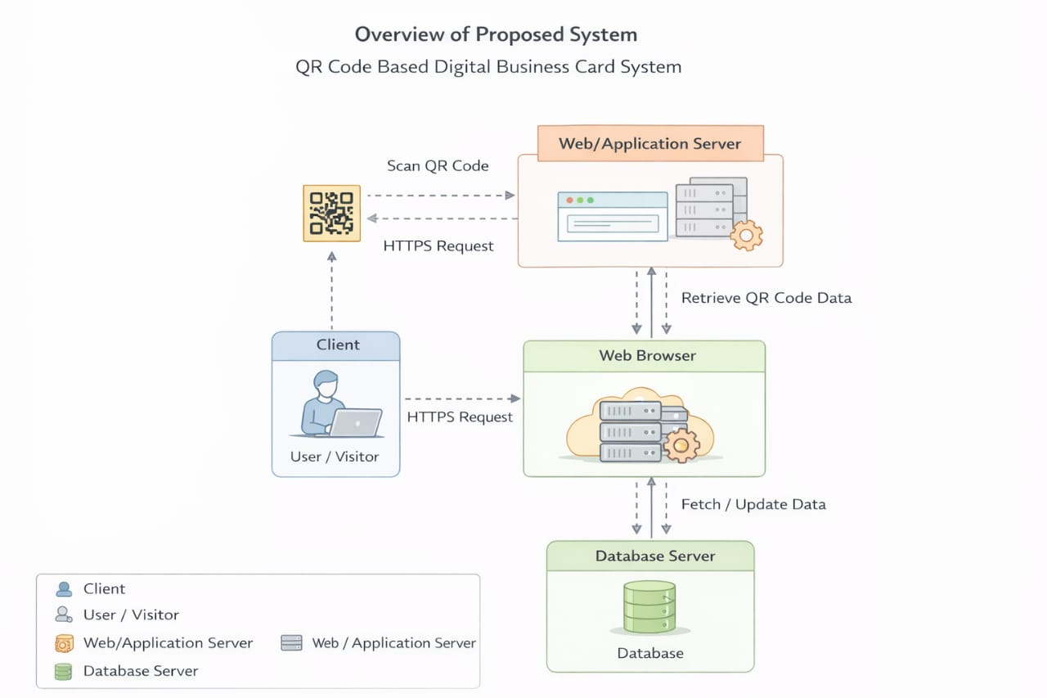
Figure 3.1: Overview Design of the Proposed System

3.3.1 Design Methodology
The system will adopt the Waterfall Model as the development methodology. The stages include:
- Requirements Analysis
- System Design
- Implementation
- Testing
- Deployment
- Maintenance
This structured approach ensures proper documentation and systematic development of the prototype.
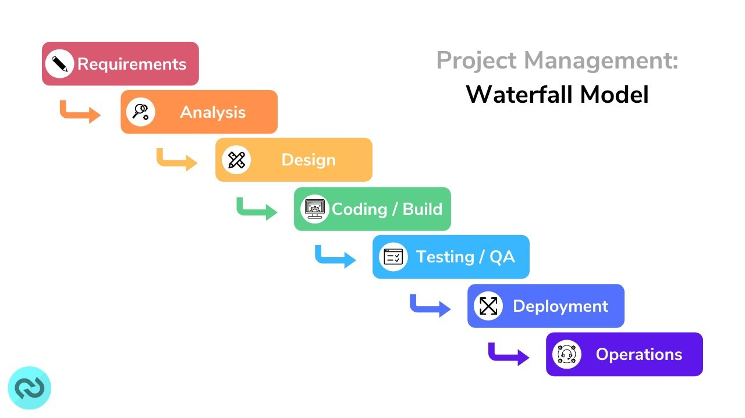
Figure 3.2: Waterfall Methodology

3.3.2 System Architecture
The system adopts a three-tier architecture, consisting of:
- Presentation Layer (Frontend)
  - Mobile-responsive web interface
  - User interaction components
  - QR code display and scanning interface
- Application Layer (Backend)
  - Business logic
  - Authentication and authorization
  - QR code generation module
  - Contact management processing
- Database Layer
  - Storage of user information
  - Storage of digital card details
  - Storage of scanned/saved contacts
This architecture ensures separation of concerns, scalability, and easier maintenance.

3.3.3 System Diagrams
(a) Use Case Diagram
Actors:
- Registered User
- Visitor/Scanner
Use Cases:
- Register
- Login
- Create Digital Card
- Edit Digital Card
- Generate QR Code
- Scan QR Code
- View Card Details
- Save Contact
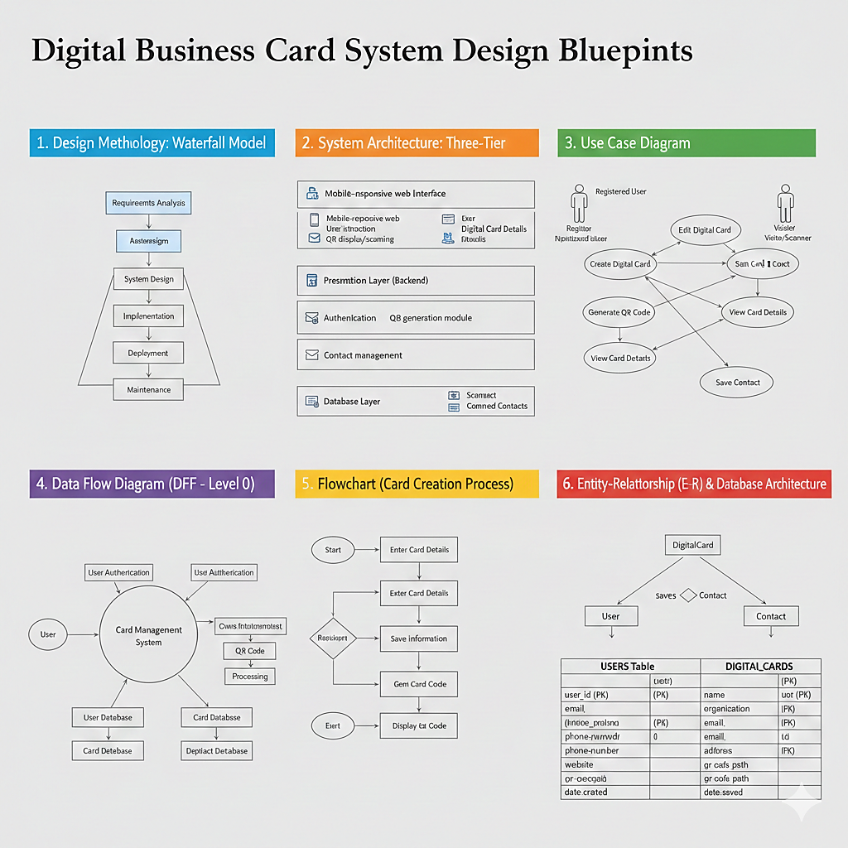
Figure 3.3: Use Case Diagram for the Proposed System

(b) Data Flow Diagram (DFD – Level 0)
External Entity:
- User
Processes:
- User Authentication
- Card Management
- QR Code Processing
- Contact Storage
Data Stores:
- User Database
- Card Database
- Contact Database

(c) Flowchart (Card Creation Process)
Start →
Register/Login →
Enter Card Details →
Save Information →
Generate QR Code →
Display QR Code →
End

(d) Entity-Relationship (E-R) Diagram
Entities:
- User
- DigitalCard
- Contact
Relationships:
- A User creates one or more DigitalCards.
- A User saves multiple Contacts.
- Each DigitalCard belongs to one User.

3.4 Database Design Architecture
The database will be designed using a relational database model. The main tables include:
- Users Table
  - user_id (Primary Key)
  - full_name
  - email
  - password
  - phone_number
  - date_created
- Digital_Cards Table
  - card_id (Primary Key)
  - user_id (Foreign Key)
  - name
  - organization
  - phone
  - email
  - address
  - website
  - qr_code_path
  - date_created
- Contacts Table
  - contact_id (Primary Key)
  - user_id (Foreign Key)
  - card_id (Foreign Key)
  - date_saved

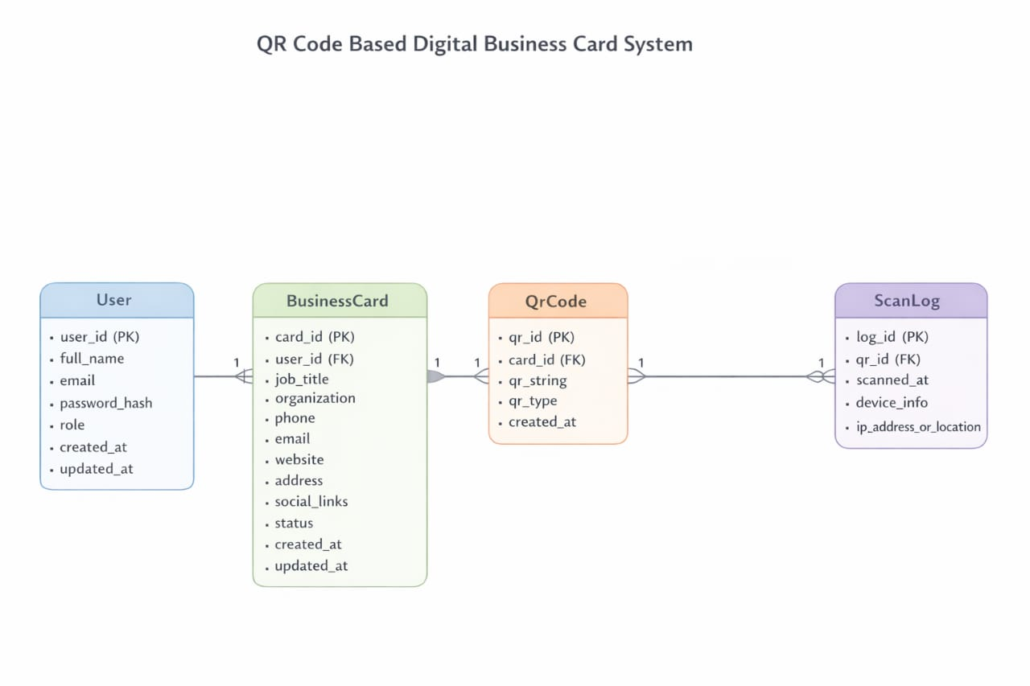
Figure 3.4: Database Design Structure
The database architecture ensures data integrity through primary and foreign key constraints and supports secure storage and retrieval of user and card information.

REFERENCES
Alibaba Product Insights. (2025, November 18). Inside dynamic QR code: Technical details, standards, and applications for professionals. Alibaba. https://www.alibaba.com/product-insights/dynamic-qr-code.html
Anonymous. (2022). A way to secure a QR code: SQR. IEEE Xplore. https://www.infona.pl/resource/bwmeta1.element.ieee-art-000008229850
Anonymous. (2024). Systematic literature review (SLR): Quick response, cryptography model and card payment systems. International Digital Organization for Scientific Research Journal of Science and Technology, 1(1), 1–15. https://doi.org/10.59298/IDOSR/JST/25/112.19000
Babiak, K., & Trendafilova, S. (2011). CSR and environmental responsibility: Motives and pressures to adopt green management practices. Corporate Social Responsibility and Environmental Management, 18(1), 11-24.
Bhamidipati, V. S., & Wvs, R. S. (2022). A novel approach to ensure security and privacy while using QR code scanning in business applications. In 2022 7th International Conference on Parallel, Distributed and Grid Computing (PDGC) (pp. 198–203). IEEE. https://doi.org/10.1109/PDGC56933.2022.10053170
Brown, A. (2022). The obsolescence of static media in professional networking. Journal of Business Communication Trends, 15(2), 45-58.
Cameron, A. F., & Webster, J. (2013). Multicommunicating: Juggling multiple conversations in the workplace. Information Systems Research, 24(2), 352-371.
Davis, D. (2025). The death of the paper business card: How smart professionals are building intelligent networking systems. LinkedIn. https://www.linkedin.com/pulse/death-paper-business-card-how-smart-professionals-don-davis-phd-mba-climc
Davis, L., & Miller, R. (2023). Physical durability and the lifecycle of business paraphernalia. Professional Material Studies, 9(4), 112-125.
Evans, M. (2025). Data entry errors and the cost of manual transcription in corporate settings. International Journal of Information Management, 31(1), 201-215.
Focardi, R., Luccio, F. L., & Wahsheh, H. A. M. (2019). Security analysis of mobile QR code reader applications. Journal of Wireless Mobile Networks, Ubiquitous Computing, and Dependable Applications, 10(4), 1-21.
Gremyr, I., Birch-Jensen, A., & Kumar, M. (2021). Digitalizing customer journeys: A study of the use of digital traces in service development. Journal of Service Management, 32(5), 697-720.
Howes, T., Smith, M., & Good, G. (2004). Understanding and deploying LDAP directory services. Addison-Wesley Professional.
Hwang, J., Park, S., & Kim, J. J. (2020). Understanding user acceptance of smart business cards: A moderating role of perceived interactivity. International Journal of Human–Computer Interaction, 36(18), 1740-1751.
Jones, T., & Smith, K. (2023). Dynamic data synchronization: Beyond the printed card. Technology & Business Innovation Quarterly, 12(3), 88-102.
Kim, H., & Lee, J. (2020). The value of digital business cards in social networking: A user acceptance perspective. Journal of Digital Convergence, 18(7), 137-146.
Krombholz, K., Frühwirt, P., Kieseberg, P., Kapsalis, I., Huber, M., & Weippl, E. (2014). QR code security: A survey of attacks and challenges for usable security. Proceedings of the 9th International Conference on Availability, Reliability and Security, 79-84.
Lee, S., & Garcia, J. (2024). Quantifying networking: The shift toward analytical contact management. Analytics in Marketing and Networking, 7(2), 33-47.
Liu, C., Wang, T., & Huang, Y. (2021). QR code security: A survey of attacks and challenges for usable authentication. IEEE Access, 9, 44058-44072.
Lubin, D. A., & Esty, D. C. (2010). The sustainability imperative. Harvard Business Review, 88(5), 42-50.
Luo, T., & Cheng, F. (2016). Business card based on dynamic information configured by two-dimensional code and implementation method (China Patent No. CN106042716A). China National Intellectual Property Administration. https://eureka.patsnap.com/patent-CN106042716A
Mobilo Card. (2026a, January 2). How to track QR code scans and analyze networking results. Mobilo. https://www.mobilocard.com/post/how-to-track-qr-codes
Mobilo Card. (2026b, November 26). Are QR codes on business cards good or bad? A practical guide. Mobilo. https://www.mobilocard.com/post/qr-code-on-business-card-good-or-bad
Narayana, V. L., & Sreeram, S. (2020). QR code based intelligent business card management system. International Journal of Advanced Science and Technology, 29(6), 1276-1284.
Okazaki, S., Li, H., & Hirose, M. (2017). Consumer privacy concerns and preference for degree of regulatory control: A study of mobile advertising in Japan. Journal of Advertising, 46(4), 493-508.
Parsons, G., & Telek, A. (2020). The vCard specification. Internet Engineering Task Force. https://datatracker.ietf.org/doc/html/rfc6350
Pitt, L. F., Parent, M., Steyn, P. G., Berthon, P., & Money, A. (2011). The social media release as a corporate communication tool for bloggers. IEEE Transactions on Professional Communication, 54(2), 122-132.
Rouillard, J. (2008). Contextual QR codes. Proceedings of the Third International Multi-Conference on Computing in the Global Information Technology, 50-55.
Shenzhen Weike Technology. (2022). An electronic business card interaction method and system based on smart wear (China Patent No. CN114091636B). China National Intellectual Property Administration. https://eureka-patsnap-com.libproxy1.nus.edu.sg/patent-CN114091636B
Thompson, H. (2021). Fragility of connections: The impact of lost physical contact data. Networking Psychology Review, 19(5), 76-89.
Ting, H. Y., T’ing, L. S., & Yap, S. L. (2021). Development of smart business card system using QR code and cloud database. Journal of Physics: Conference Series, 1878(1), 012045.
University of Idaho Parks and Recreation Lab. (2025, November 6). Exploring validity of QR code survey data collection in an era of declining response rates. UI Parks and Rec Lab. https://www.uidahoprl.com/post/exploring-validity-of-qr-code-survey-data-collection-in-an-era-of-declining-response-rates
Venkatesh, V., Thong, J. Y., & Xu, X. (2012). Consumer acceptance and use of information technology: Extending the unified theory of acceptance and use of technology. MIS Quarterly, 36(1), 157-178.
Wilson, P., Greene, D., & Roberts, S. (2024). The environmental footprint of the printing industry: A push for digital alternatives. Sustainability and Corporate Responsibility Journal, 22(1), 14-29.

